**The Mevagissey Male Voice Choir**

will be in concert

at 7.30 pm on Saturday 9th July 2022

at

Yealmpton Community Methodist Church, Chapel Road, Yealmpton, PL8 2LZ

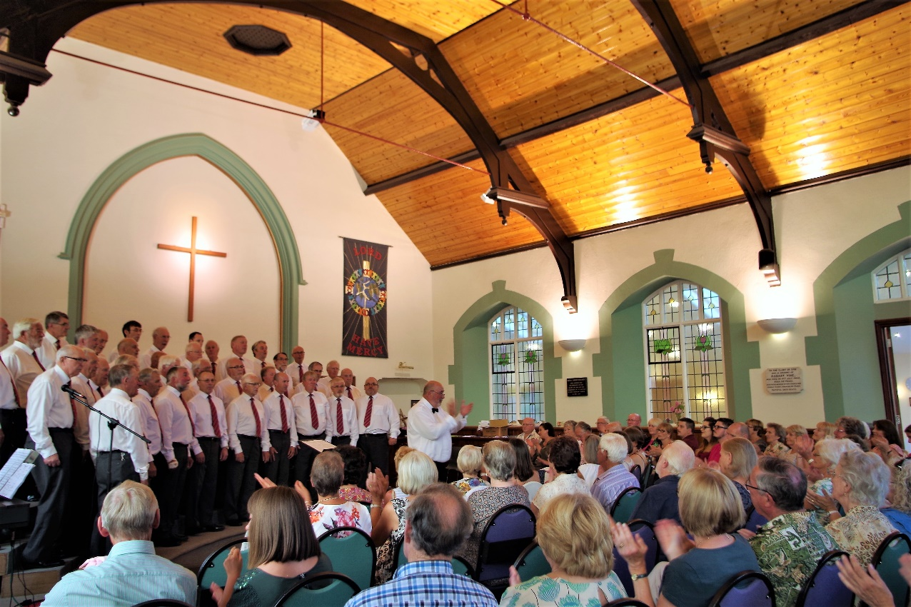

Donations of minimum of £5.00 per head, on the door,

in aid of



Celebrating 10 Years of Support